PROJECT 4

Windows User Accounts
and File Permissions
Practical Windows administration and basic access-control inspection

1. Project Overview
This project involved exploring Windows account settings and inspecting the security permissions assigned to a test folder. The exercise provided practical experience with local user accounts, sign-in options, User Account Control (UAC), and NTFS file permissions.

2. Objectives
- Locate and review the Windows account information page.
- Explore the Other users and Sign-in options settings.
- Review the User Account Control notification level.
- Create or use a test folder named Project4_Permission_Test.
- Open the folder’s Properties and inspect its Security tab.
- Identify the permission entries for SYSTEM, the signed-in USER account, and Administrators.

3. Practical Tasks Performed

A. Reviewing Windows account settings
The Accounts section in Windows Settings was explored. The Your info page showed that the device was using a local account with administrator status. The Other users page was also opened to review where additional user accounts can be managed. Sign-in options were inspected, including Windows Hello availability, PIN, security key, and password options.

B. Reviewing User Account Control (UAC)
The User Account Control Settings window was opened. The notification level was observed at the Windows default setting: notify when apps try to make changes to the computer, without notifying for changes made by the user to Windows settings. The setting was not lowered or disabled.

C. Inspecting folder security permissions
The Properties window for Project4_Permission_Test was opened and the Security tab was selected. Three permission entries were reviewed: SYSTEM, USER (TM1_LAPTOP\USER), and Administrators (TM1_LAPTOP\Administrators). The Allow permissions displayed for the signed-in USER included Full control, Modify, Read & execute, List folder contents, Read, and Write. No permission changes were made during the inspection.

4. Screenshot Evidence
The screenshots below document the Security tab and the three permission entries reviewed.

Figure 1. Security tab with SYSTEM selected. The folder’s security entries are visible.
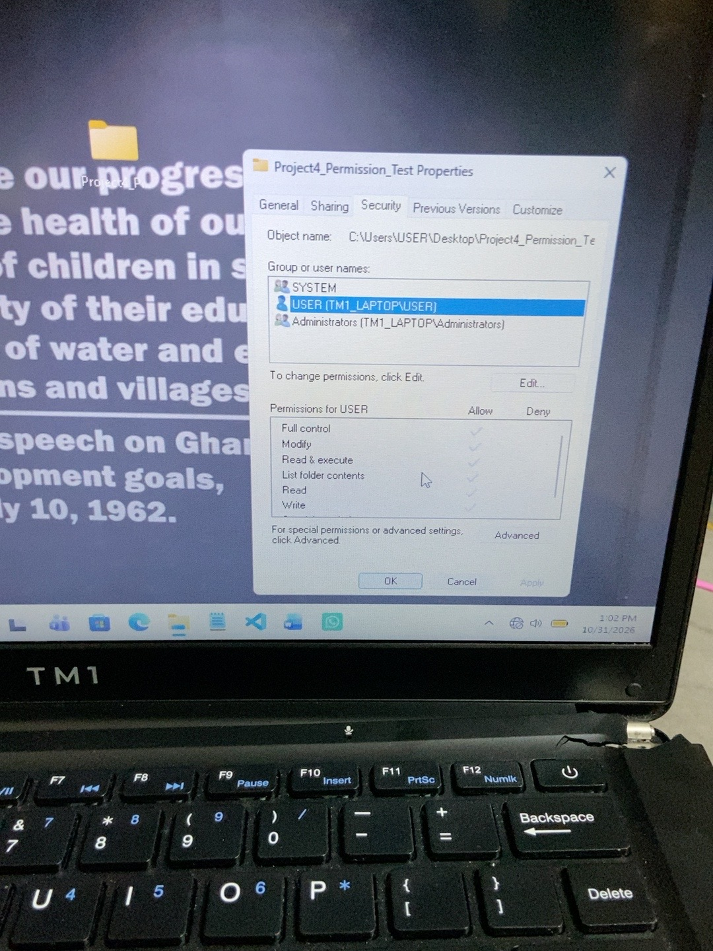
Figure 2. USER (TM1_LAPTOP\USER) selected. The Allow permissions include Full control and other standard access rights.
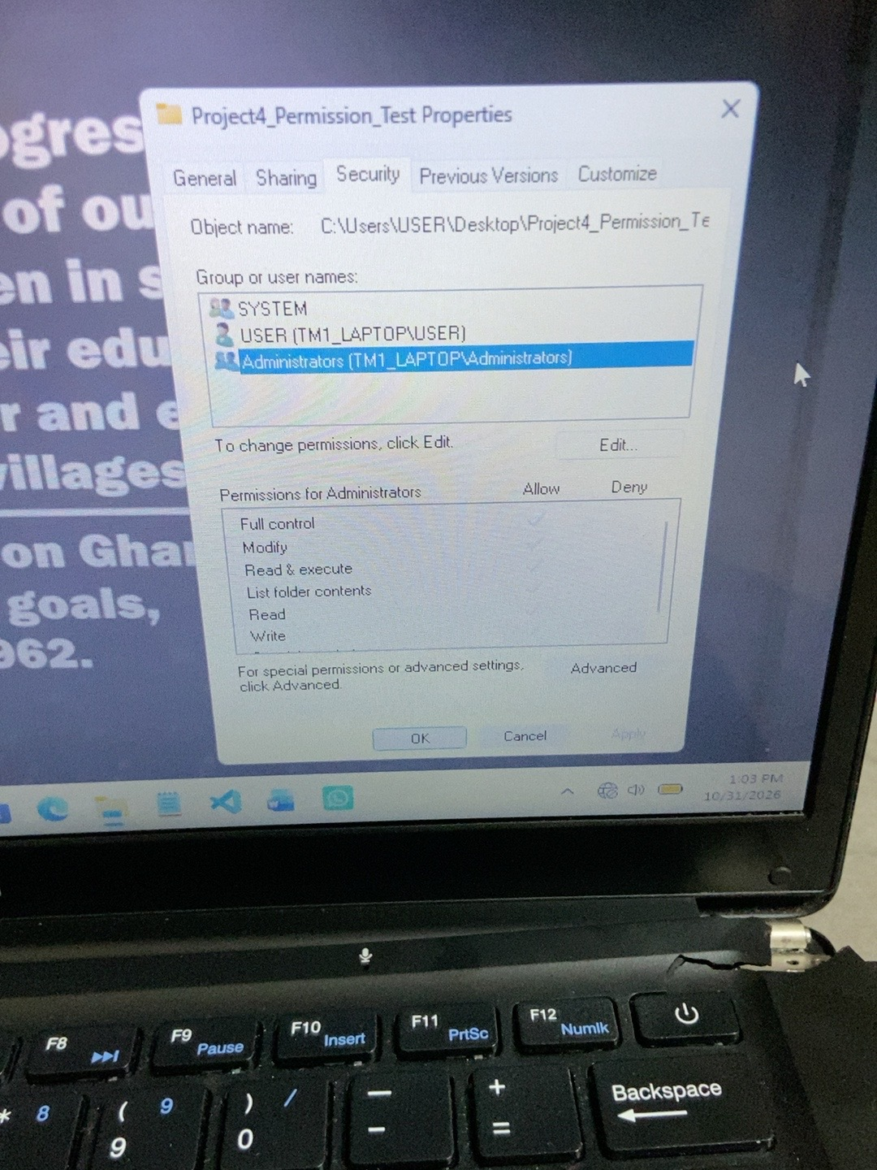
Figure 3. Administrators (TM1_LAPTOP\Administrators) selected for permission inspection.

5. Key Learning Outcomes
- Windows Settings provides a central location for managing account information and sign-in methods.
- A local administrator account has elevated privileges for managing the computer.
- UAC helps protect Windows by prompting before applications make certain system-level changes.
- The Security tab displays which users and groups have access to a folder and what actions they are allowed to perform.
- SYSTEM, an individual user account, and the Administrators group are separate security principals.

6. Result and Conclusion
The account-related settings and folder permissions were successfully located and inspected. The test folder showed separate permission entries for SYSTEM, the signed-in user, and Administrators. This exercise strengthened practical understanding of Windows account management, UAC, and basic file-system access control. No security permissions were changed.

7. Skills Demonstrated
Windows Settings navigation • Local account awareness • UAC configuration awareness • Folder properties inspection • NTFS permissions awareness • Basic troubleshooting documentation

